**AI ASSISTED CODING**

NAME: Sharikha Imtiaz Khan

ROLL NO: 2403A52368

TASK 1:

write a python program class named student with attributes name, roll_number and marks which display details and check if marks are above average using functions

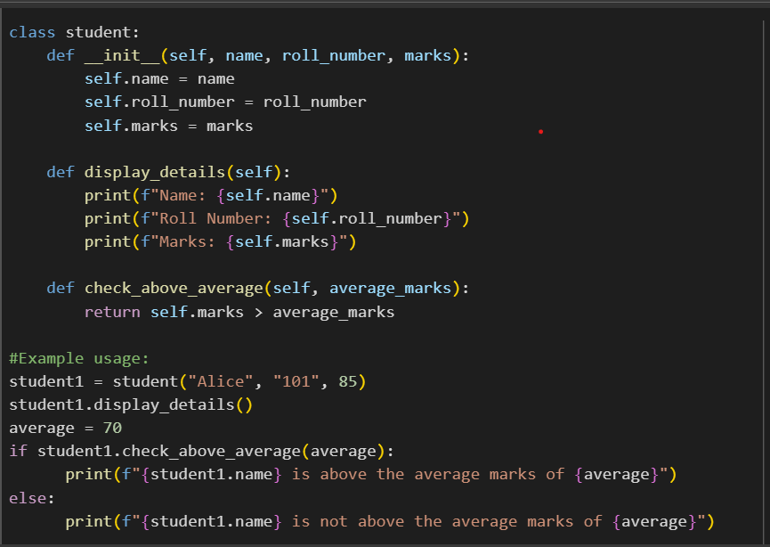

EXPLANATION:

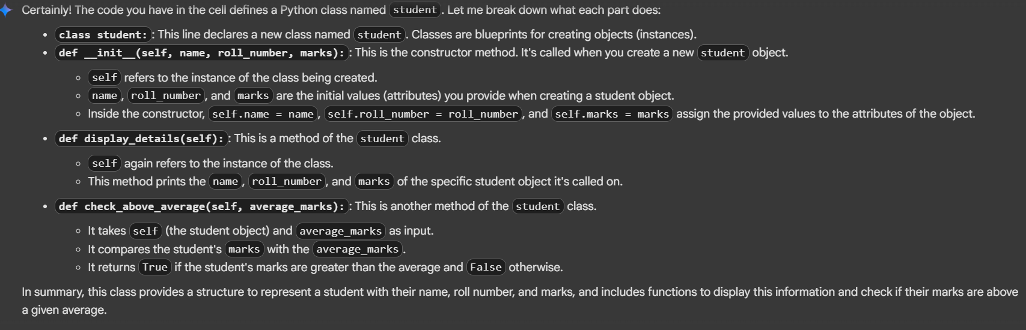

OUTPUT:

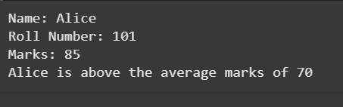

TASK 2:

Write the first two lines of a for loop to iterate through a list of numbers that should calculate and print the square of even numbers only using functions

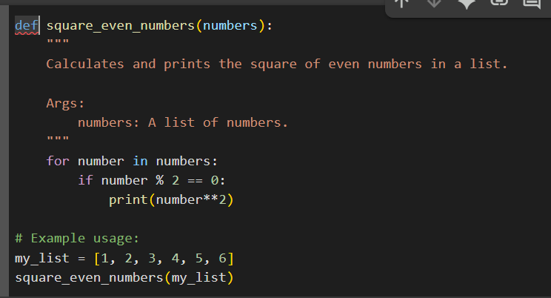

EXPLANATION:

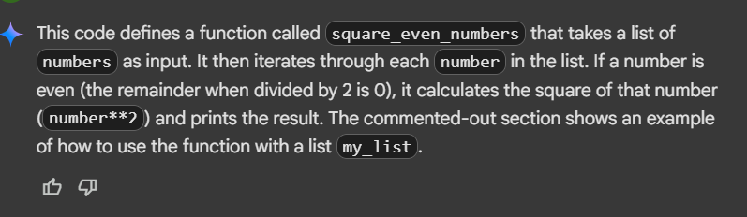

OUTPUT:

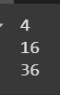

TASK 3:

Write a python program a class called bankaccount with attributes account_holder and balance complete it with methods like deposit(),withdraw() and check for insufficent balance using functions

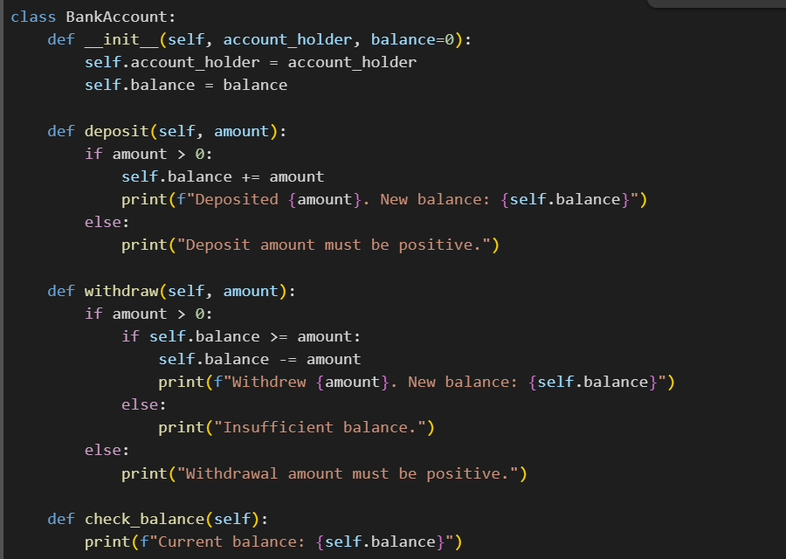

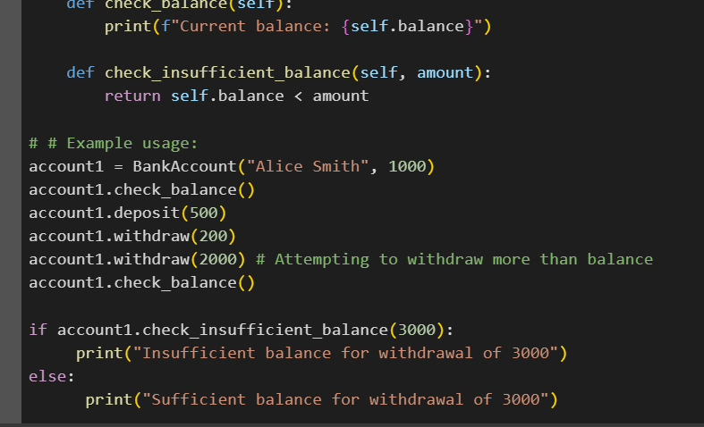

EXPLANATION:

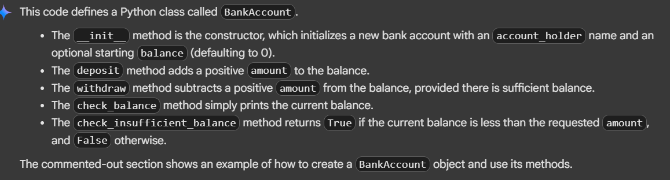

OUTPUT:

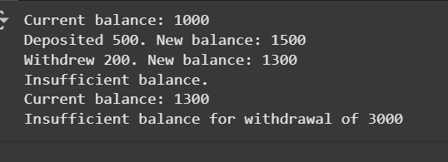

TASK 4:

Write a python program with list of student dictionaries with keys name and score write a loop to print the names of student who scored more than 75 using functions

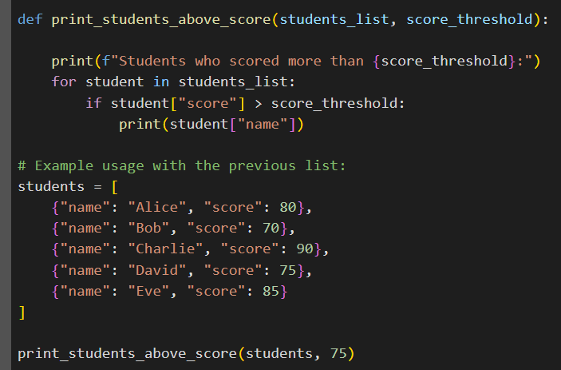

EXPLANATION:

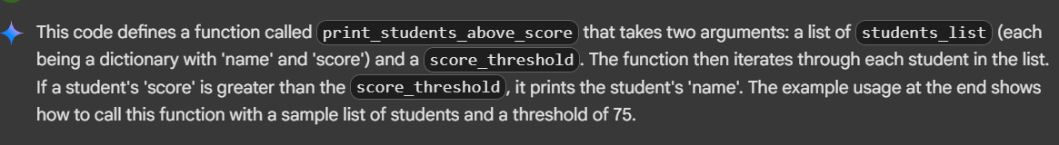

OUTPUT:

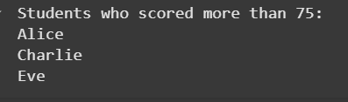

TASK 5:

Write a python program with generated loops and if else statements containing a class shoppingcart with an empty items list it should generate methods like additem,remove_item ad calculate the total bill using conditional discounts using functions

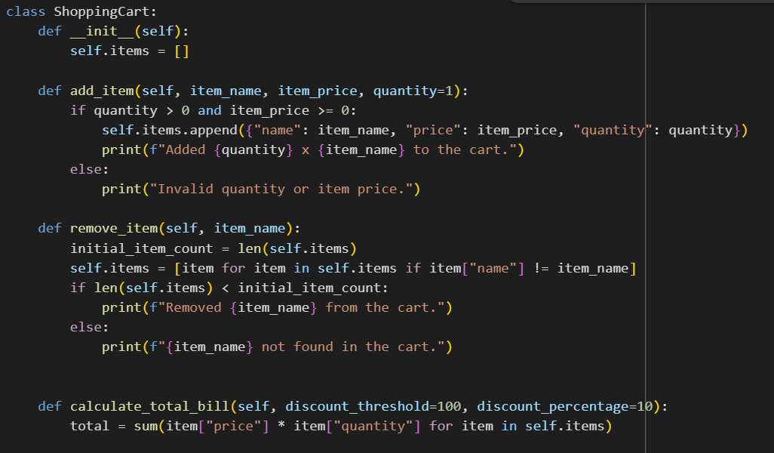

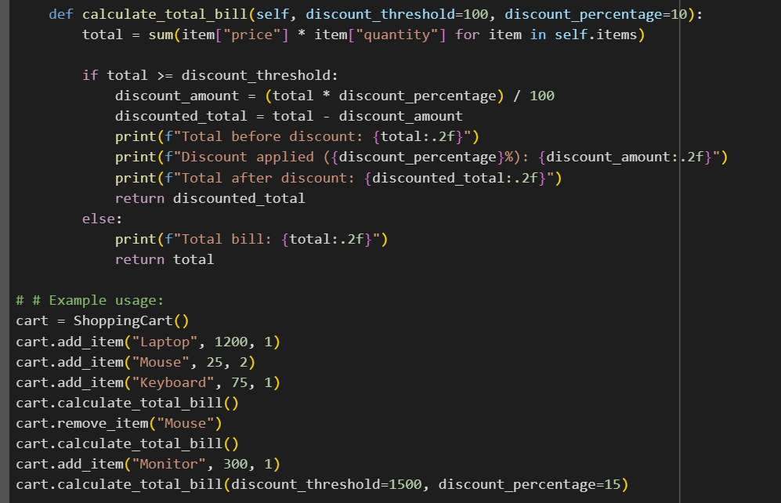

EXPLANATION:

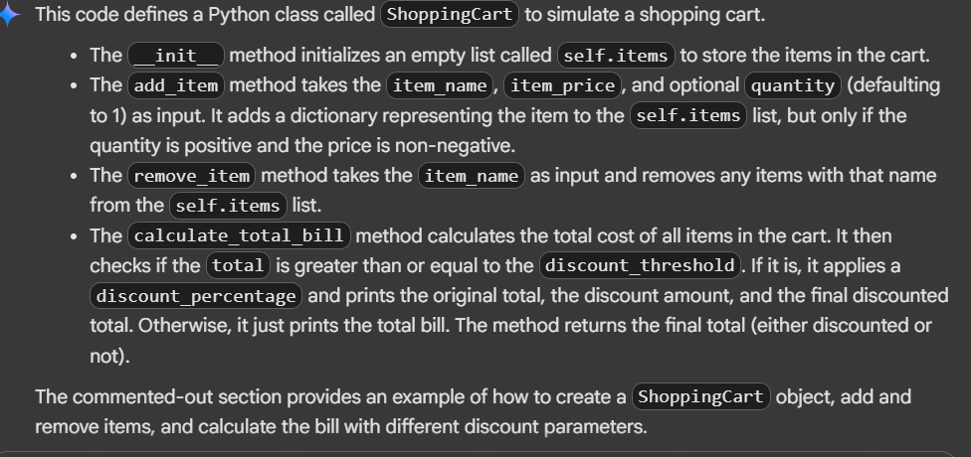

OUTPUT:

